Viewing Project Information
Viewing task usage, resource usage
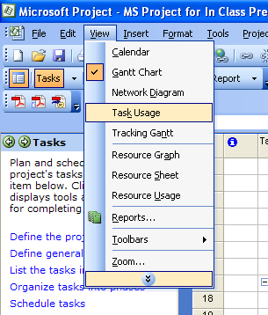
- We will be going over the task usage and resource usage views. They provide information corresponding to specific task names and resources name that are categorized with their respective tasks.
Task Usage Sheet
- Click on the View from the menu, click a Task Usage.
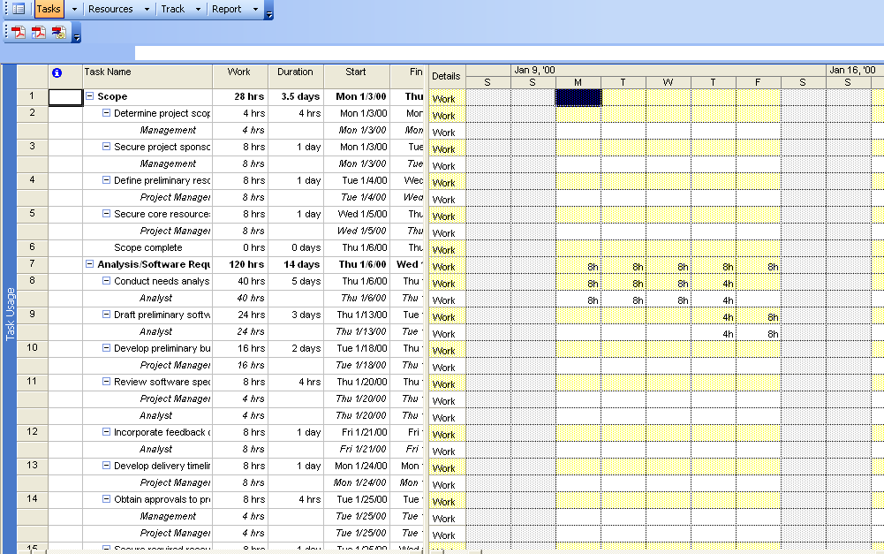

The task usage sheet provides you with information of certain task names that can also be collapsed. Also, it provides you with work in hours and the duration in days. The start and finish dates are also provided with this usage sheet.
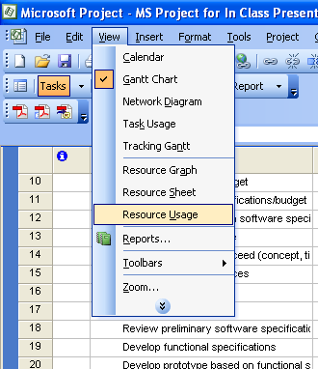
Resource Usage Sheet
- Click on the View from the menu, click on Resource Usage.

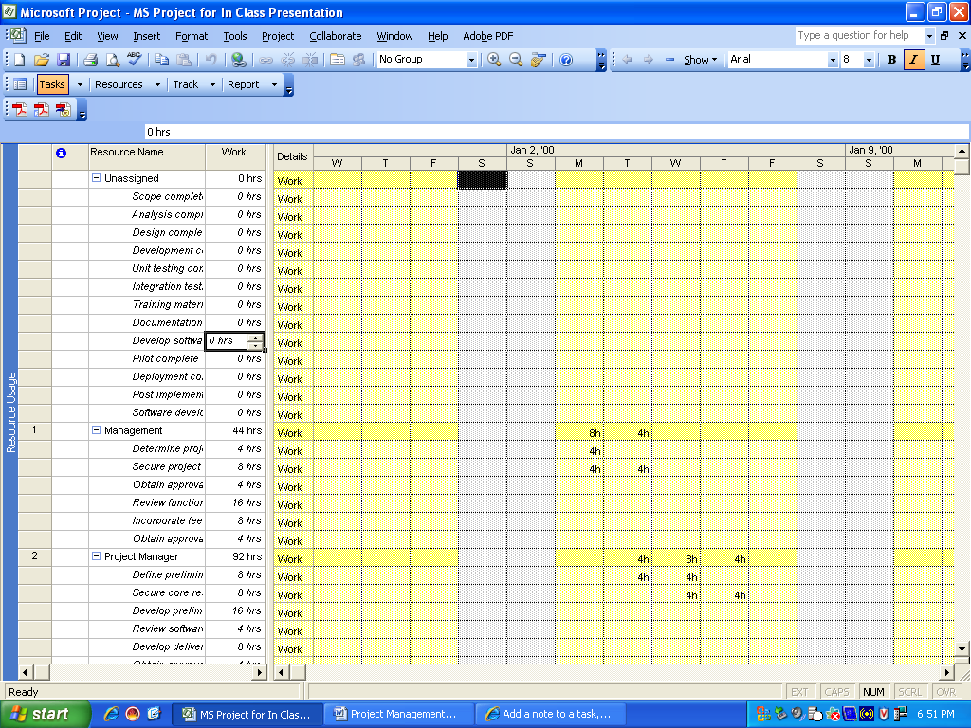

The Resource Usage view provides the user with resource name date. Depending on how many resources are within each category (Unassigned, Management, Project Manager, Analyst, etc) all the resources are provided with a collapsible tab. The resource outline level is provided with total hours for all the resources and within each specific resource the exact work in hours is provided. The resource sheet also provides warning symbols near resource outline levels that need to be leveled on a day to day basis. Normally, this is within a certain amount of hours.

View Assignment Report

- Click on View from the menu, click on Reports.
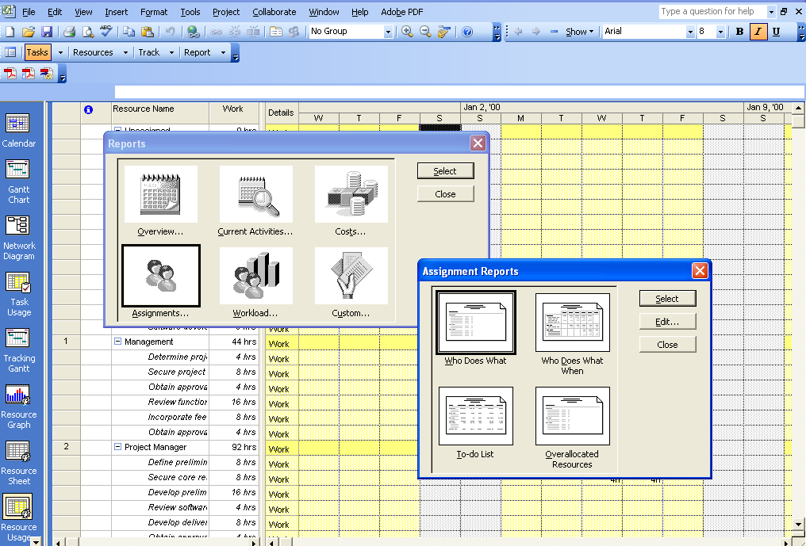
- Click the Assignment tab and select.

After selecting assignments you are presented with four different options in MS Project. Those options are Who Does What, Who Does What When, To-Do List, Overallocated Resources

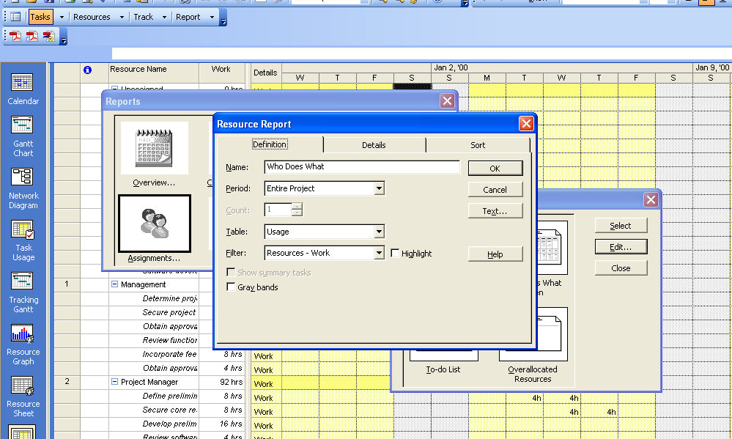
Depending on which assignment option you want to select you can edit each selection and set certain parameters in the Resource Report. The parameters in our Definition tab can change the name, period or more so durations of time. Depending on the time selected like half year, quarters, etc., you can set a count function. Also, you can choose a specific table and then apply a filter.

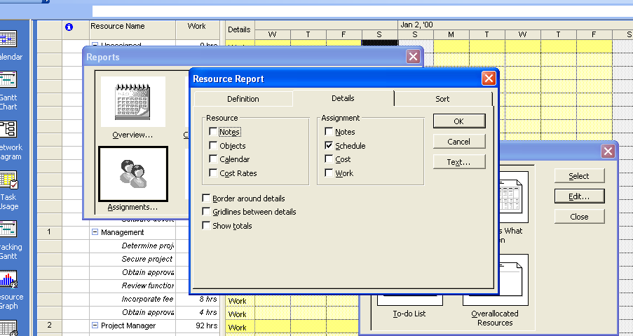
Also, in the Resource Report you can view Details.

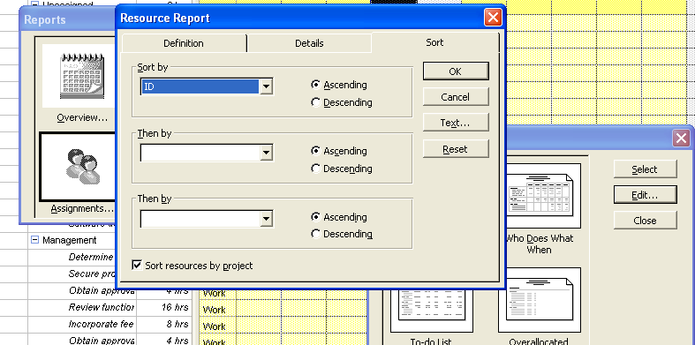
Within the Detail tab you can apply resource options like Notes, Objects, etc. and you can also apply assignment options like notes, schedule, coct, etc. Finally, you can further your report with borders around details, gridlines between details and show totals on your reports.

The final tabbed option in our Resource Report is Sort. This is where you can sort ID’s, work variance, WBS, etc. in ascending or descending order and further sort your report by other variables.

The Who Does What Assignment Report
- Click on View from the menu, click on Reports.
- Click the Assignment tab and select.
- Click on Who Does What and select.

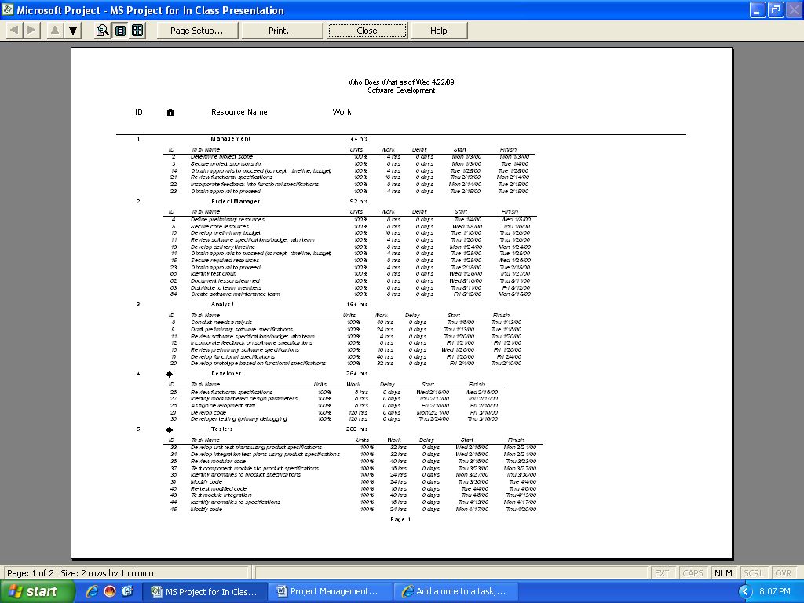

This report provides the software development up to a certain date. The task names are categorized in their respective resource names provided with work in hours. Also, the work is provided with delays in hours and the task names are given starting and finished dates.
The Who Does What When Assignment Report
- Click on View from the menu, click on Reports.
- Click the Assignment tab and select.
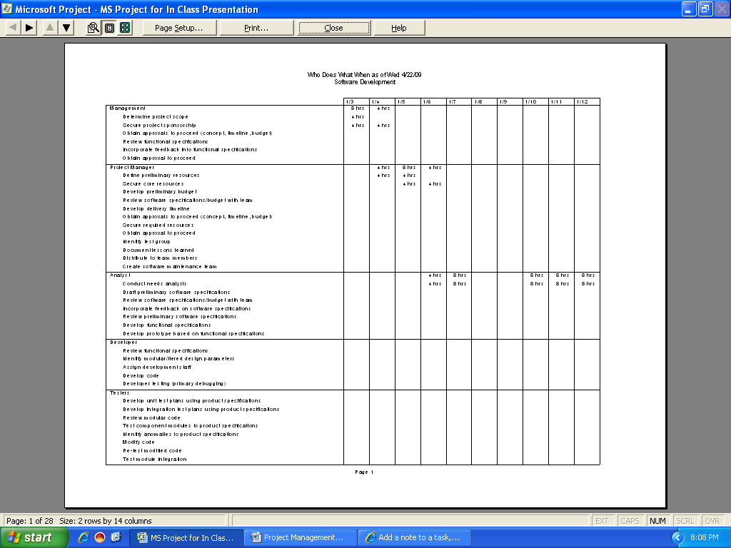
- Click on Who Does What When and select.

The Who Does What When Report provides resource names categorized with their task names provided with a weekly outline of how many hours that task took on a specific date.

The To-Do List Assignment Report
- Click on View from the menu, click on Reports.
- Click the Assignment tab and select.
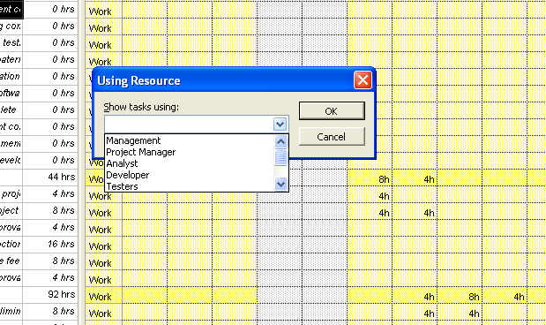
- Click on To-Do List and select.
The report is dependent on which tasks you will show using certain resources. I chose tasks using Management.
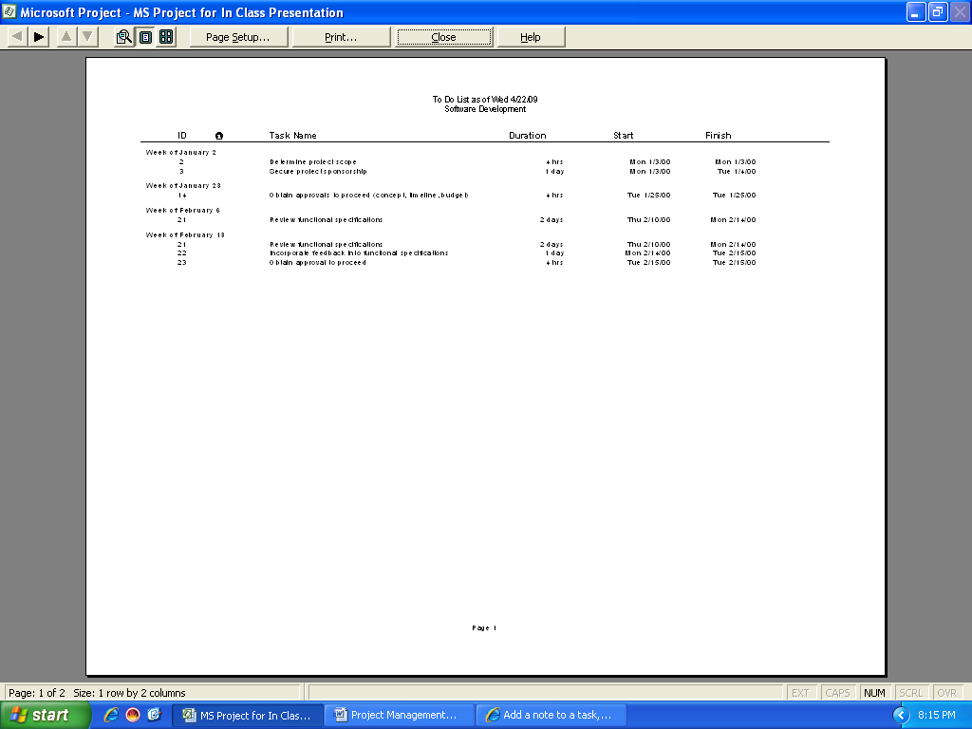

The To-Do List Report shows tasks names up to a certain date the duration in days that particular task took. The ID’s are sorted depending on date.

The Overallocated Resources Assignment Report
- Click on View from the menu, click on Reports.
- Click the Assignment tab and select.
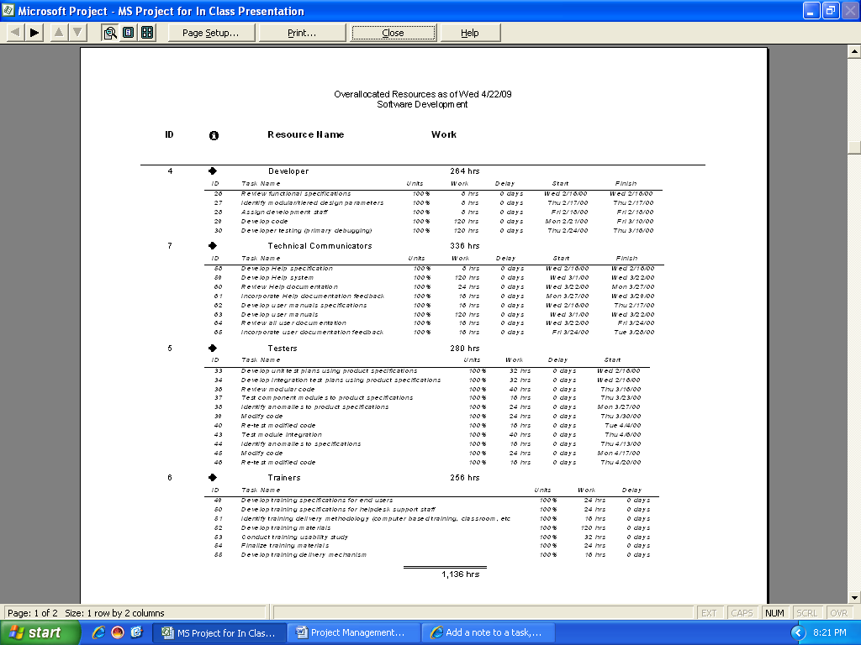
- Click on Overallocated Resources tab and select.

The overallocated resource report provides particular resource names with their tasks worked in hours. The tasks have are 100% because there have been no delays for any of the tasks. Each resource has the total number of hours worked with the combined total of hours of all the resources accomplished up to a specific point in time.
Viewing Workload Reports
- Click on View from the menu, click on Reports
- Click on Workload tab, click on select.
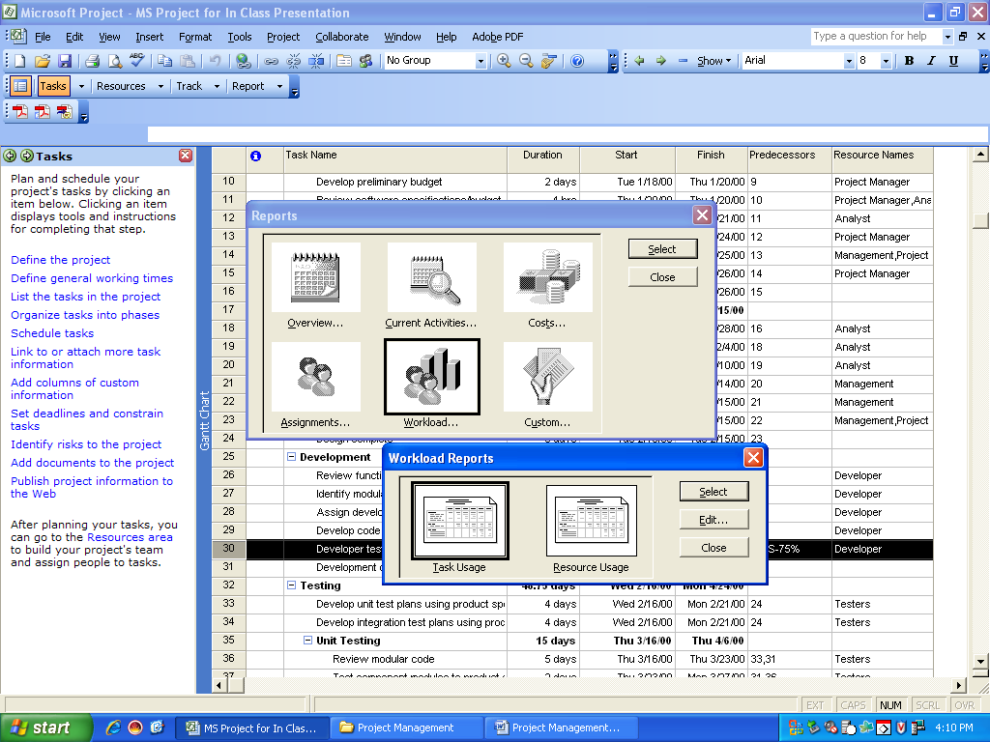
- Click on Task Usage tab, click on select.

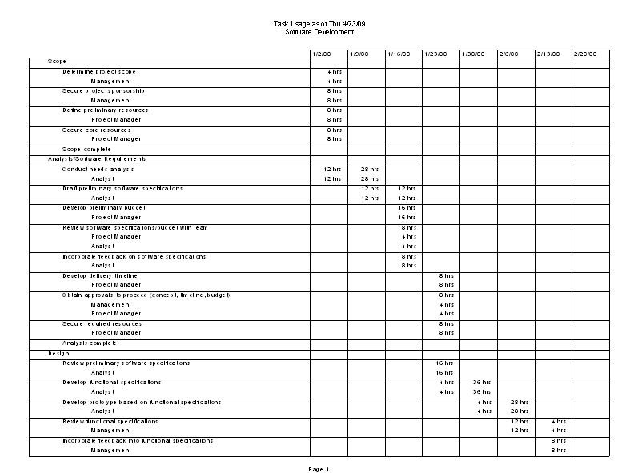
You are provided with this screen:

The task usage workload report displays information on certain tasks corresponding with their particular resource names in hours worked on a particular day. Depending on how you edited the task usage report your information could be different.
Workload Report: Resource Usage
- Click on View from the menu, click on Reports
- Click on Workload tab, click on select.
- Click on Resource Usage tab, click on select.
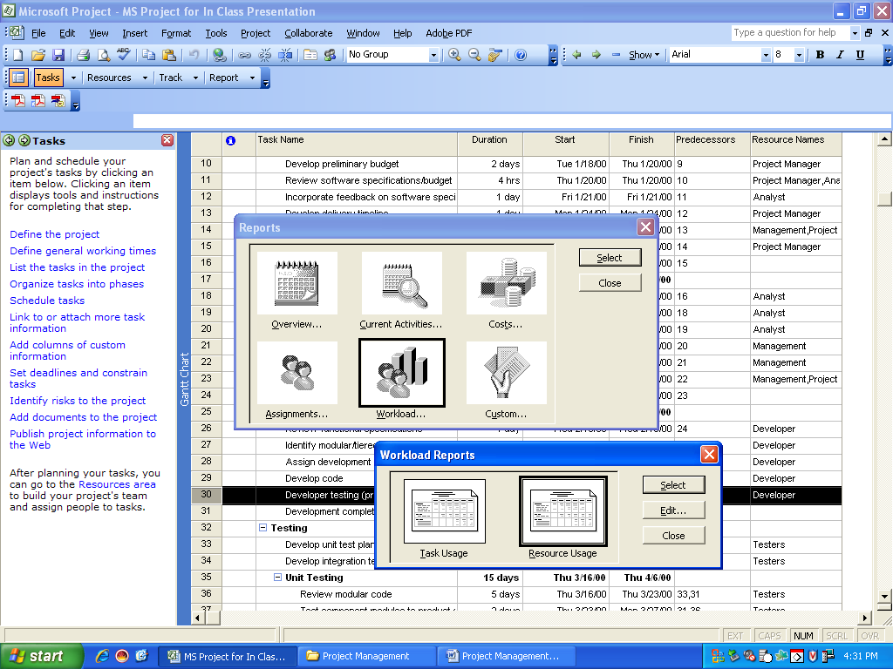

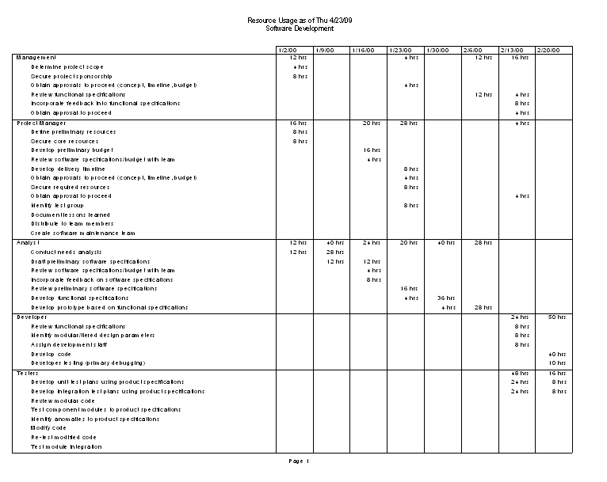
You are then provided with this screen:

The resource usage report provides information corresponding in resources by their respective resource names. The rows are resources and the columns are provided by work in hours for a specific day. At the bottom of the report the hours are totaled up. You can further edit this report’s rows, columns, name and specific filters etc.

Custom Report
- Click on View from the menu, click on Reports
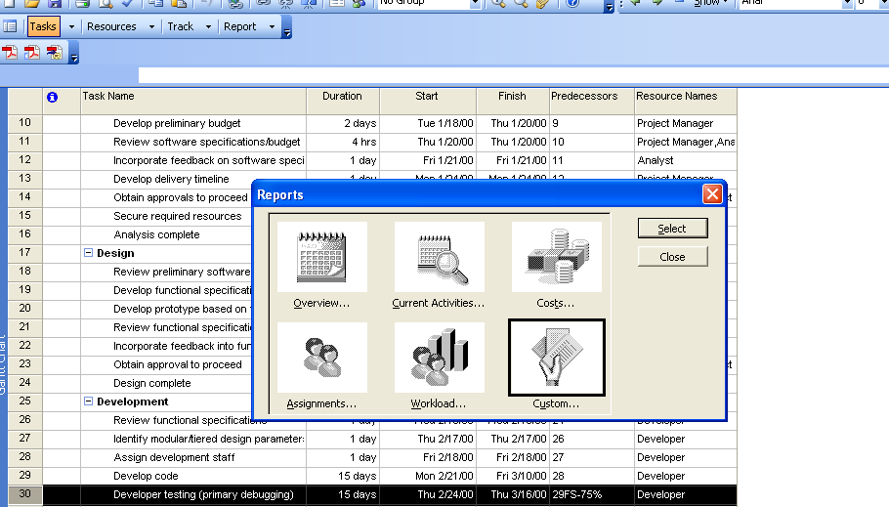
- Click on Custom tab, click on select.

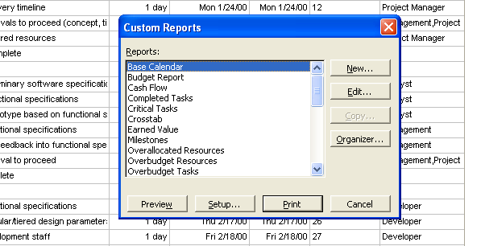
You are presented with this window:

From here you can preview up to 30 default reports for your project. You can further print, organize, copy, or even edit each specific report. You can also create your own personal report editing the details, definition and sortation of your report.

Viewing Data in MS Project

As the project is being populated, a Gantt chart is generated. The Gantt chart is the default view for MS Project. Gantt charts are used to graphically display the scheduling of various activities in a project. They include the start and finish dates as well as the relationship of tasks of a project.

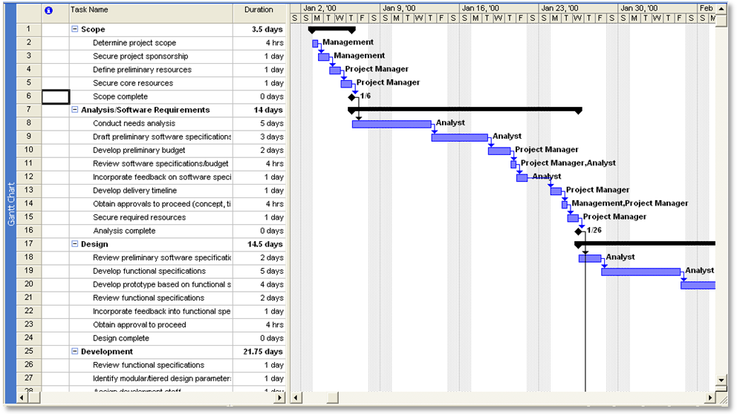

If the Gantt chart is not viewable,
- Left click on “View” in the task bar.
- Scroll down and select Gantt chart.
- Your view will immediately switch to the
Gantt Chart
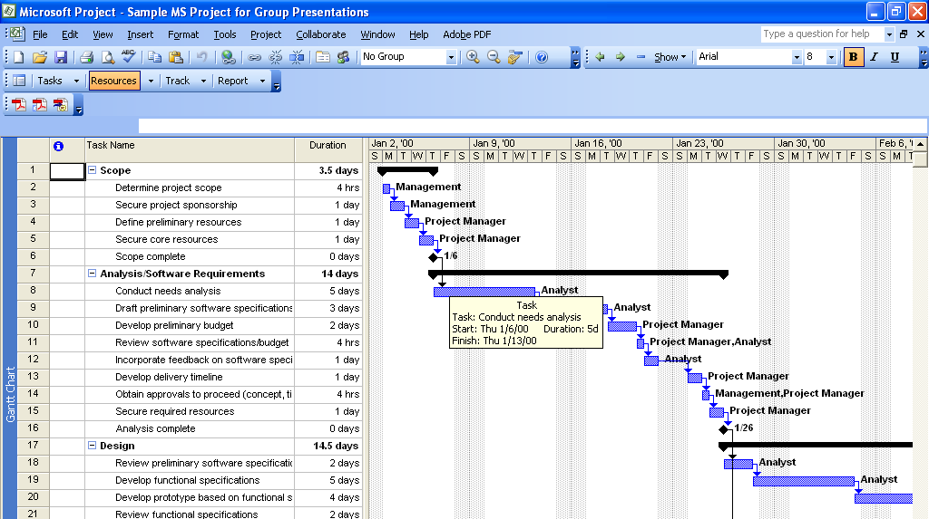
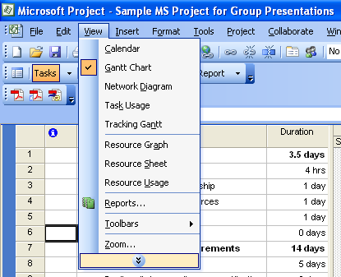

One of the most interesting functions that the Gantt chart is capable of is consolidating a large amount of data. The Gantt chart will automatically update itself to the changes that are made to the data. This is an important function when presenting a project to a project sponsor or other board members that do not need to see all the details, but require a schedule of how the project will progress. This is also beneficial if the project schedule it required as part of an executive summary.

Notice that if the roll-up bars are condensed so that only the parent information is shown the Gantt chart will also show just an overview of the work that is to be done.
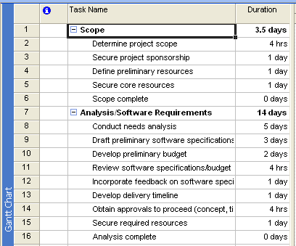

- Left click on a number of the roll-up bars
- Notice how the Gantt chart condenses the
work into the parents.

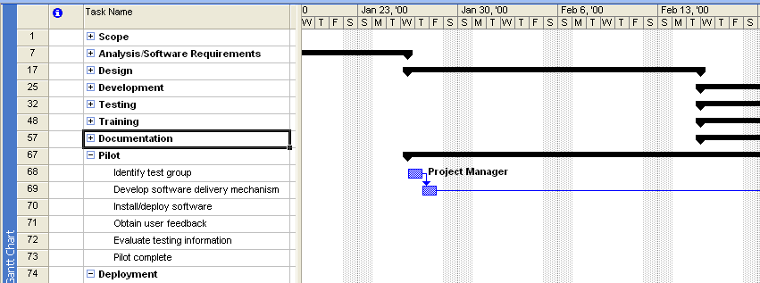

The Gantt chart also graphically shows how each relationship in the project is dependent on the previous tasks and has a direct impact of the following tasks. It is valuable in identifying tasks that can be delayed and those that must be placed as top priority if the project is to be completed on time.

Another feature of MS Project that lets you view data is the Calendar view. This too can be accessed in the same manner as the Gantt chart. The calendar view is particularly helpful in the day to day progress of the project. It can be referenced as a means to keep the project on track.

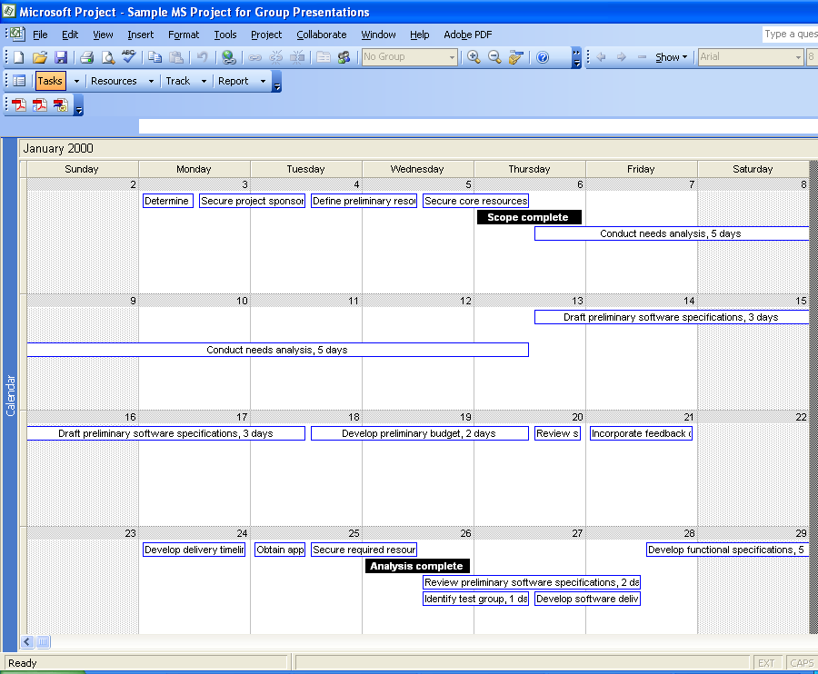
- Left click on “View” in the task bar
- Scroll down and select Calendar.
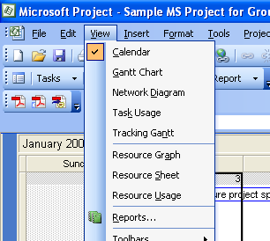

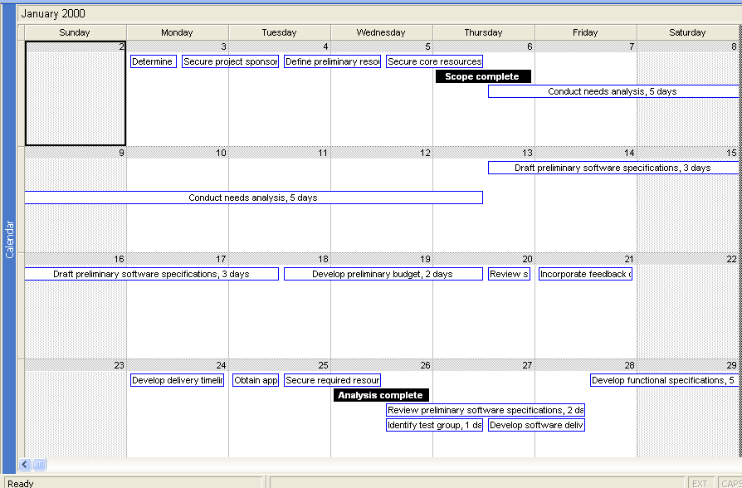

Another interesting function of both the calendar function as well as the Gantt chart is the ease at which you can see the task information.

- Double left click on either the data on the Gantt chart or any of the data on the calendar.
- Notice the task information that is easily available, including predecessors, resources, and any notes on the task.
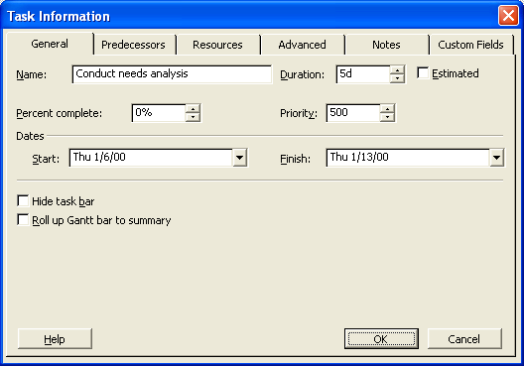

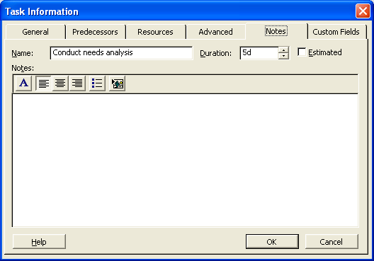
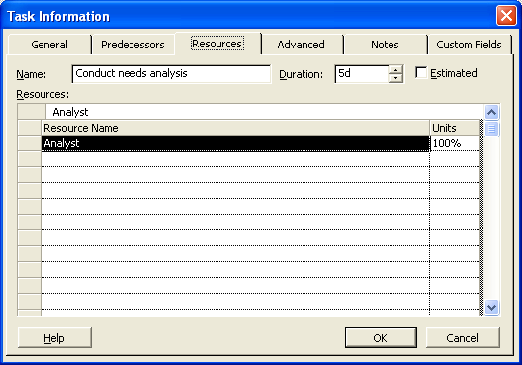
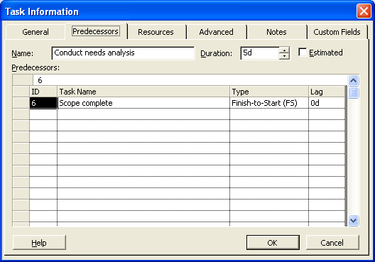

The next area that can be utilized in viewing data is the network diagram. The network diagram is used to represent the flow and sequence of work activities in the project. It details the task ID, start date, finish date, duration and resources used.

- Left click on “View” in the task bar.
- Scroll down and select Network Diagram

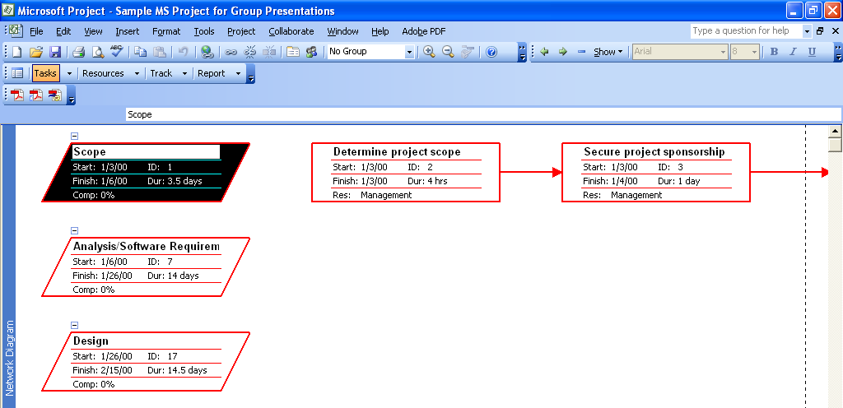
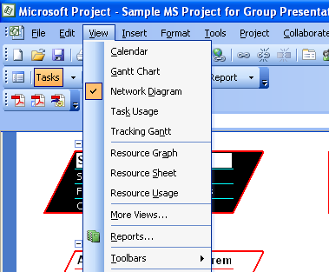

One of the more interesting graphical displays that are available in MS Project is the Resource Graph. It allows you to view each resource and how much they are being utilized and on what day they are needed.

- Left click on “View” in the task bar.
- Scroll down and select Resource Graph.
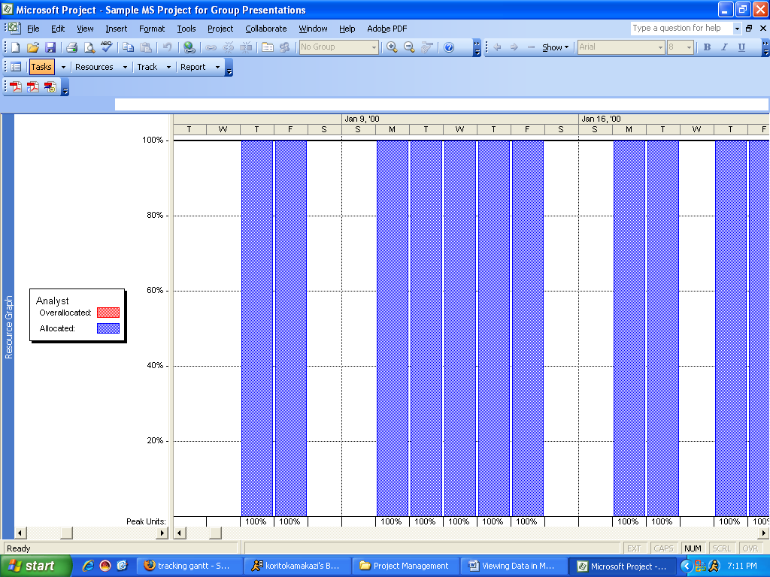
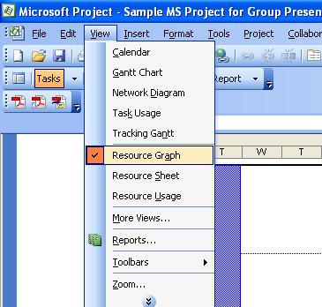

Notice that in this view you can scroll between various resources such as management, analyst, developer and tester by using the small scroll bar at the bottom. Then each resources usage is displayed on the right with the percentage and day it needs to be used.

Another way to view data is the Resource Sheet. This sheet introduces cost rates and figures into the viewing process. It is also utilized to level resources. Notice that the resources listed in red have the indicator that if they need to be leveled, it should be based on a day to day decision

- Left click on “View” in the task bar.
- Scroll down and select Resource Sheet.
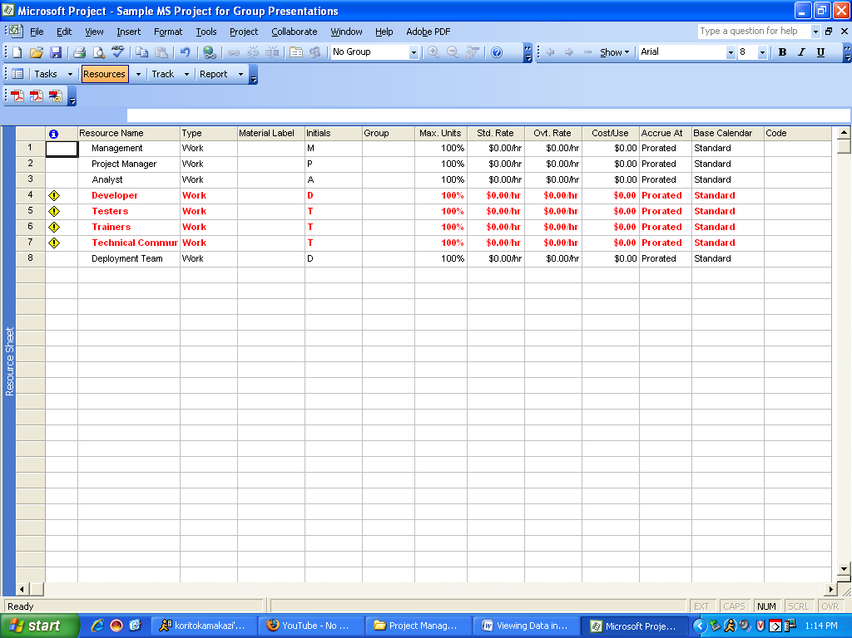
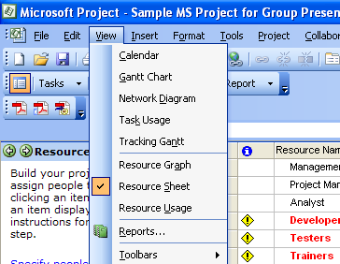

- Double left click on any cell in the resource sheet to see more detailed information about that resource
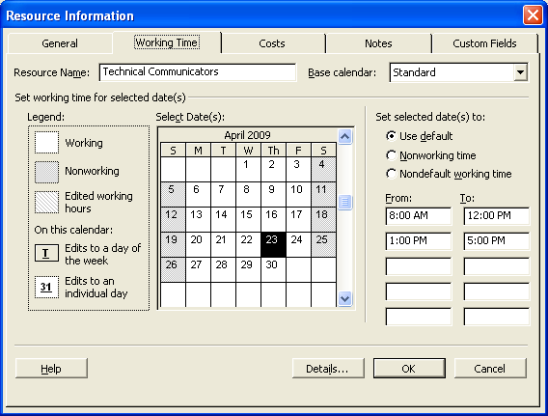

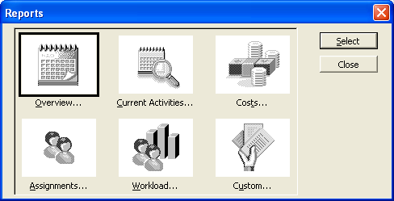
Perhaps the most powerful viewing option in MS Project is the ability to generate detailed reports from the data. These can be of great benefit to many aspects of business, and are very valuable for decision making and monitoring the progress of the project.

- Left click on “View” in the task bar.
- Scroll down and select Reports…
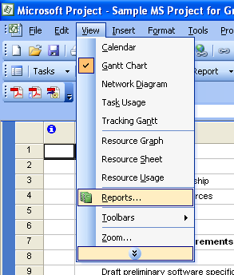

Notice that there are 6 areas where detailed reports can be generated; overview, activities, costs, assignments, workload, and other reports
The first area in the reports is the overview section. While this area is highlighted left click Select. This will then open up the option for 5 different overview reports; project summary, top-level tasks, critical tasks, milestones, and working days. Again while anyone of them is highlighted left click Select to view the detailed report.

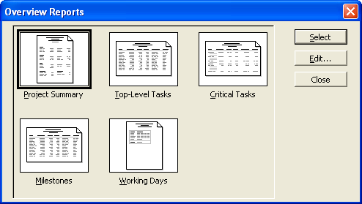

Let’s look at a few of the overview reports.

- Left click on Overview
- Left click on Select button
- While Project Summary is highlighted, left click Select

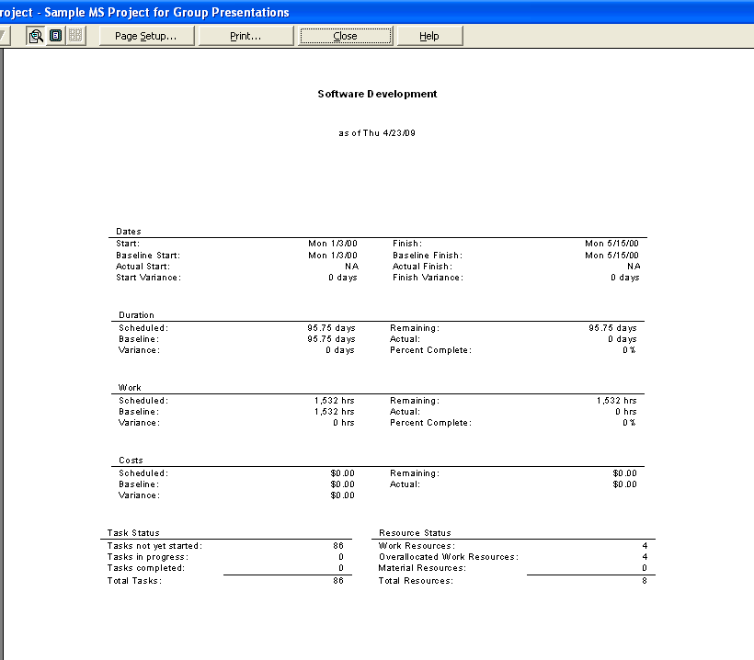
Notice that Selecting any of the reports will automatically open them in the Print Preview mode. Here one can scroll thru multiple pages, if they are generated, and make superficial changes to the document prior to printing as well as zooming in and out on for more or less detail.

The Project Summary report provides a brief glimpse of how the project is to proceed.

              - Left click the close button to go back to the Report grouping.
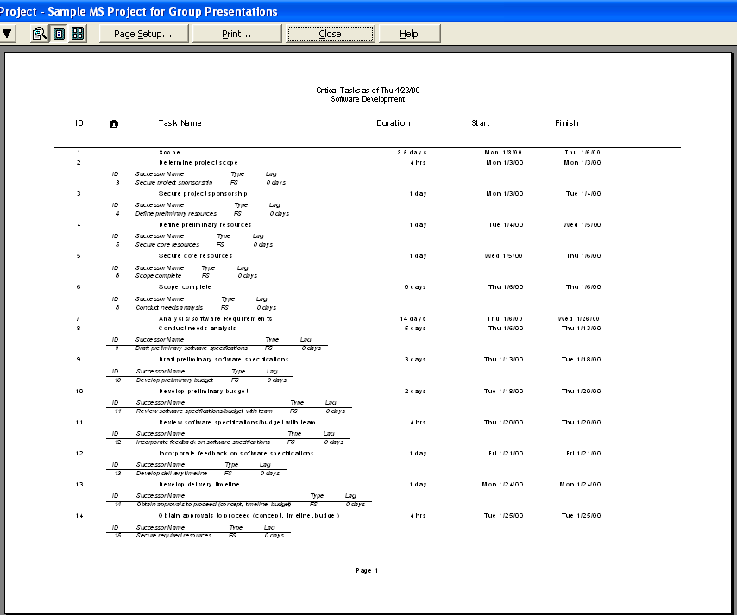

Next let’s look at the critical tasks.

- Left click on Overview
- Left click on Select button
- Highlight Critical Tasks
- Left Click the Select button

This report provides a list of tasks that are critical to
the completion of the project. All of these tasks have
a lag time of zero (0), meaning they must be finished
as scheduled in order for other tasks and the project
as a whole to be finished on schedule.

- Left click the close button to go back to the Report grouping.
The final report in the Overview group that we will view is the Milestones report.

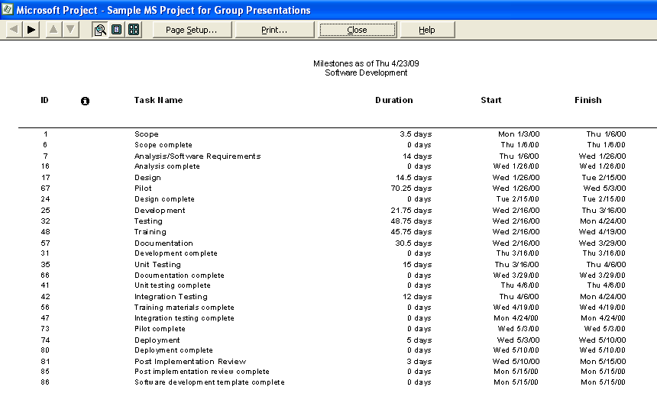
Left click on Overview
- Left click on Select button
- Highlight Milestones
- Left Click the Select button

Listed are all the milestones that will
be achieved throughout the project.
At each milestone, there should be some
kind of recognition made of the
achievement.

- Left click the close button to go
back to the Report grouping.

Now let’s move on to another area of reporting. Highlight the Current Activities reports and left click select. Again a number of reporting options are available; unstarted tasks, tasks starting soon, tasks in progress, completed tasks, should have started tasks, and slipping tasks. Special interest should be paid especially to the last option, slipping taks. This report shows were immediate attention is needed in order to advert and risk.
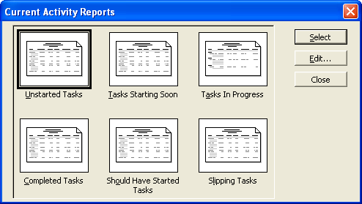
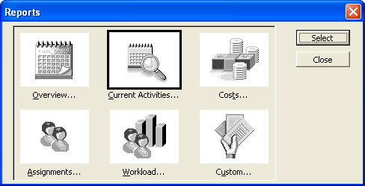

However, let’s notice the first option, unstarted tasks.
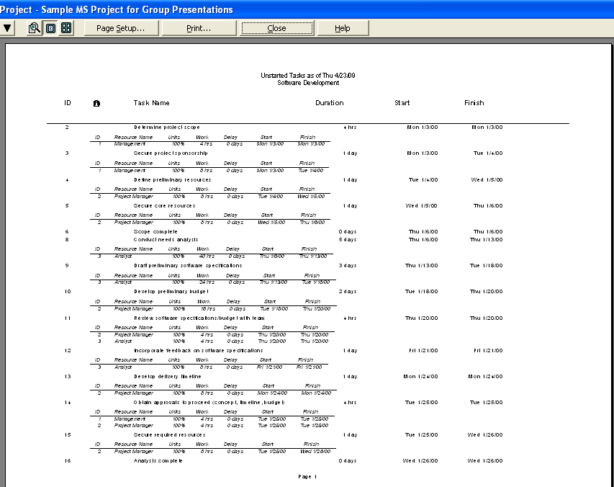
- Left click on Current Activities
- Left click on Select button
- Highlight Unstarted Tasks
- Left Click the Select button

Here is a list of the remaining activities that must be completed for the project to be finished. This report is valuable in determining progress once the project has been underway for some time.

- Left click the close button to go back to the Report grouping

Perhaps one of the most widely used types of reports is the cost reports. The risk of running over budget is always a danger for a project manager. These reports allow the project manager to see cash flows, budget, over budget tasks, over budget resources and earned value. Once the project has been operating for some time, there is much more detail revealed in these reports. But for now, let’s just look at a few of the cost reports, starting with the cash flow.
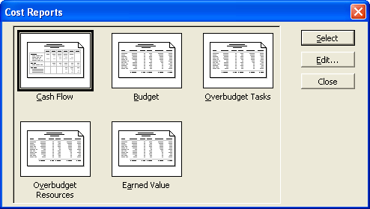
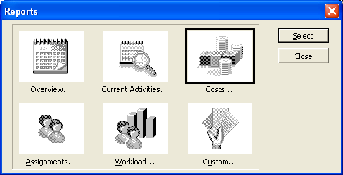

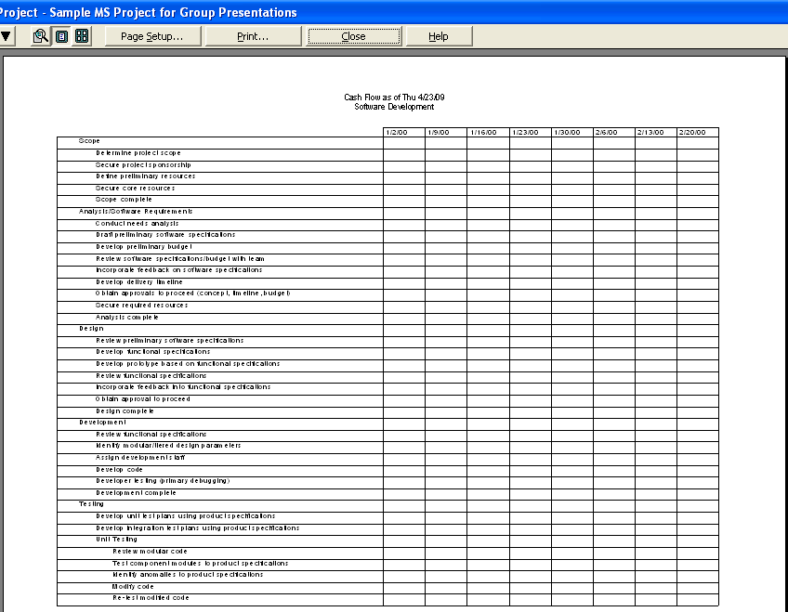
- Left click on Costs….
- Left click on Select button
- Highlight Cash Flow
- Left Click the Select button

Once the project has begun, the
cash flow cost report will outlay
spending details at each task level and
the date which it was spent. This
report also keeps a running total at the
end.

- Left click the close button to
go back to the Report grouping

The next cost report to look at is the Budget. This report generates costs per task. It details the costs into fixed cost, total cost and variance in dollars. It also keeps a total of all budgeted costs.
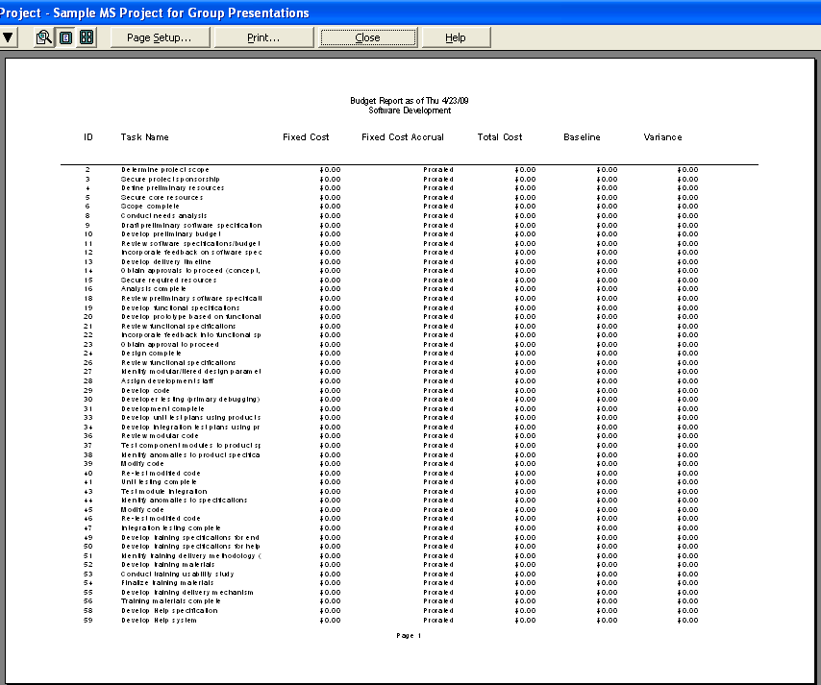

- Left click on Costs….
- Left click on Select button
- Highlight Budget
- Left Click the Select button

              - Left click the close button to
go back to the Report grouping

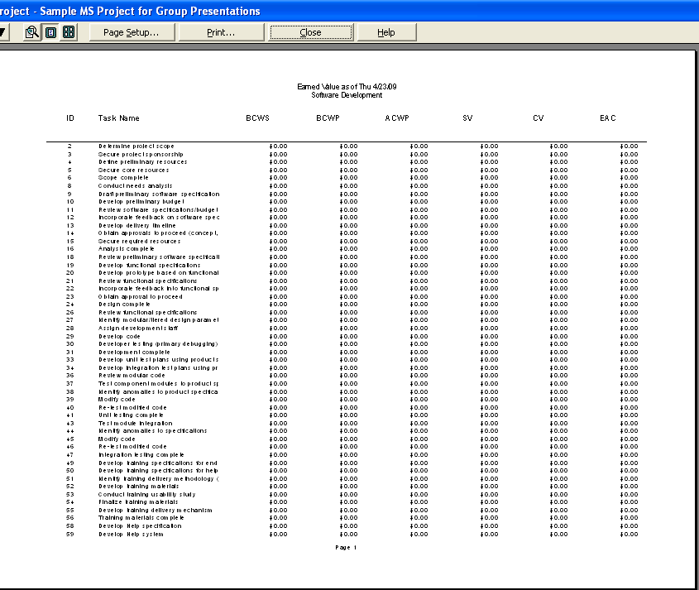
The last cost report that we want to look at is the Earned Value report. This is important for the project manager as well as the project sponsor and any board members. Every project is expected to have inherent value, and this report details exactly which tasks are providing that value.

- Left click on Costs….
- Left click on Select button
- Highlight Earned Value
- Left Click the Select button

a. Left click the close button to go back to the Report grouping

It needs to be mentioned once again for emphasis that MS Project is a dynamic tracking application. Once the project is underway, new data will be added to the project resulting in more robust details in the reports. However viewing the reports now provides an appreciation for the breadth and depth of what MS Project provides.

There is one last feature with regards viewing data that MS Project provides. If there should ever occur a situation that calls for a different or unique view of data that has not been covered to this point, MS
Project provides many more options under the View selection in the task bar.

- Select View from the task bar.
- Scroll down and select More Views…
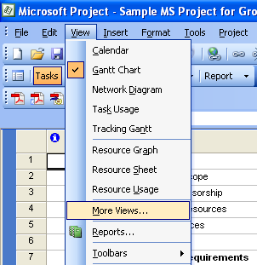
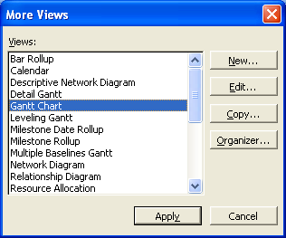

That has been just a brief overview of all the different ways that MS Project allows you to view the data. As the multitude of additional views indicates, there is any number of unique ways to view data in MS Project. Please take the time to explore the various other project views.

Now we would like to turn the presentation over to ________________ who will discuss______________.

